**Project** : IOt Based smart crop protection system for agriculture

**Project Design Phase-1**:Solution fit  **Team Id:** **PNT2022TMID2477**

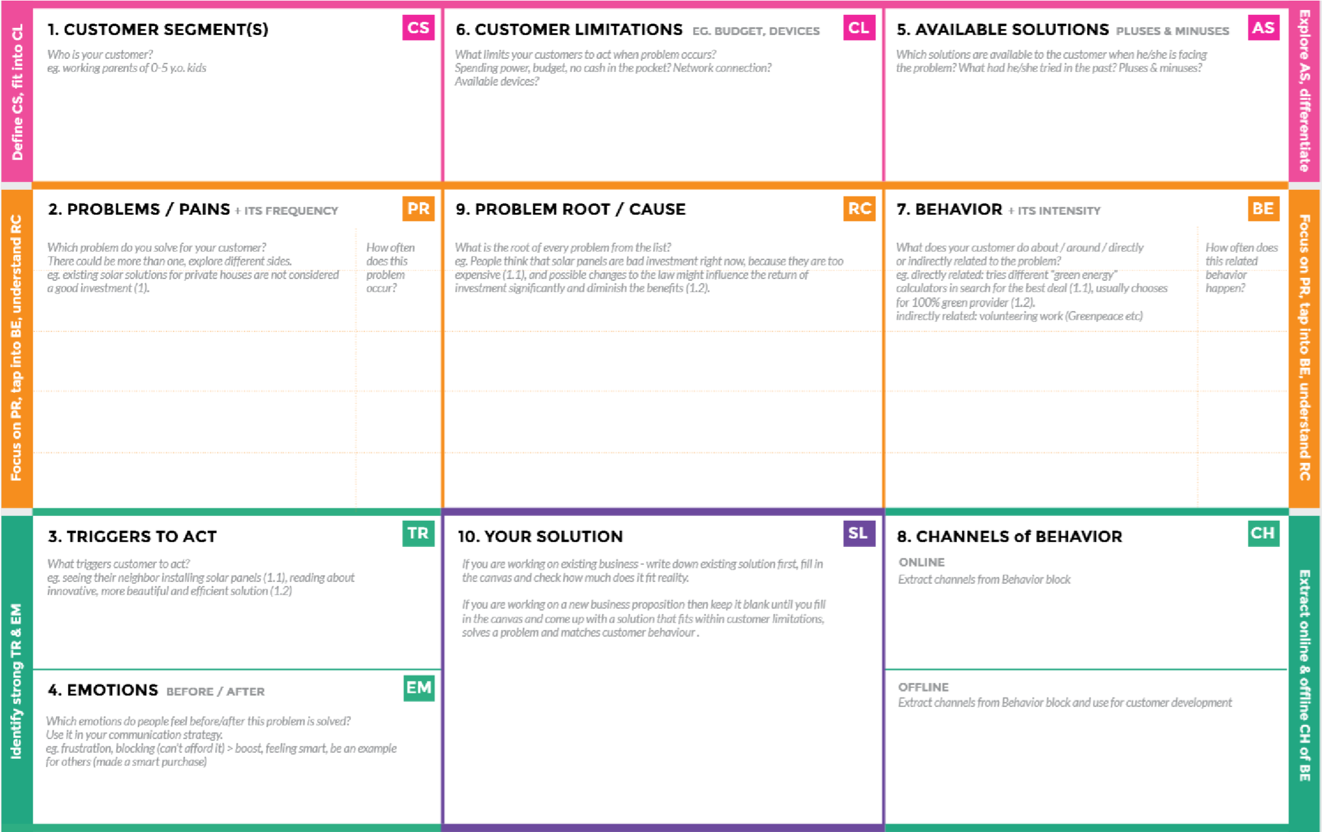

Farmer’s ! Who’s not near his

field

•

It’s difficult to monitor and

control

•

Ain’t known if the application

doesn’t work properly

.

Create

opportunities to lift people out

of poverty in developing nations. (Over

60

)

%

**BEFORE**

Finances, Heavy work

:

overload and

conflict in relationship.

**AFTER**

It will

:

easier to

make more

yield in

***“IoT***

***based Smart crop protection system***

***for agriculture” !!***

It help farmers grow more food on less

land by protection crops from pests,

diseases and weeds as well as raising

productivity per hectare.

1)

High adoption costs , security concerns.

2)

Not aware of the implementation of IoT in

agriculture.

If

,humidity

level

,PH

temperature

1)

&

light

intensity

makes

the

serious

the

for

cause

environment.

Farmer affected by less productivity which

2)

will affect in their profit.

Monitor

different parameters and mobile

or web application make easily to farm the

crop field .

**Direct related**

Tries to find a solution to

:

prevent this problem

**Indirect related**

Located in rural where

:

internet connectivity might not be strong

enough to facilitate fast transmission speeds.

**ONLINE:**

The Data send through application

for the farmers to know about the farms.

**OFFLINE**

:

The control action is taken by

the farmers to monitor the farms.